Evaluation: Random Forest
Accuracy: 0.9494310998735778
Precision: 0.9579035253544211
Recall: 0.9494310998735778
F1 Score: 0.9521880693456444
Jaccard Index: 0.9167765345439315
Matthews CorrCoef: 0.9351127422900545
Cohen’s Kappa: 0.9342799458287291
Specificity: 0.9920532764952297
AUC: 1.0
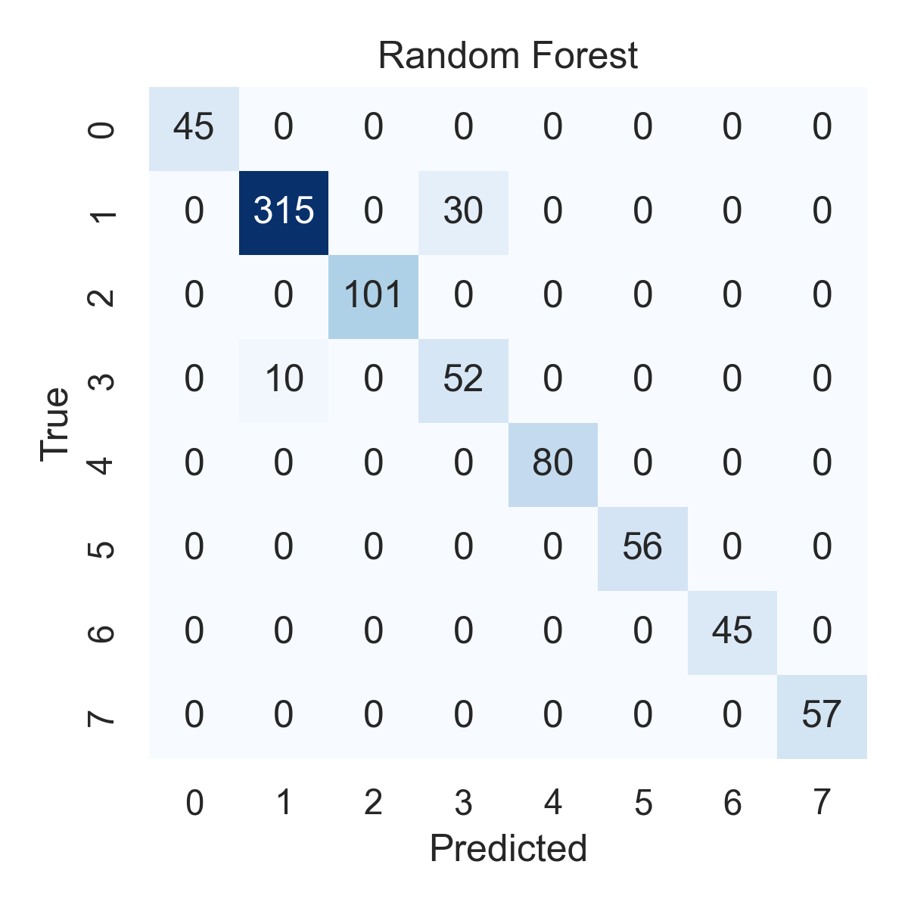

Combined ROC Curves
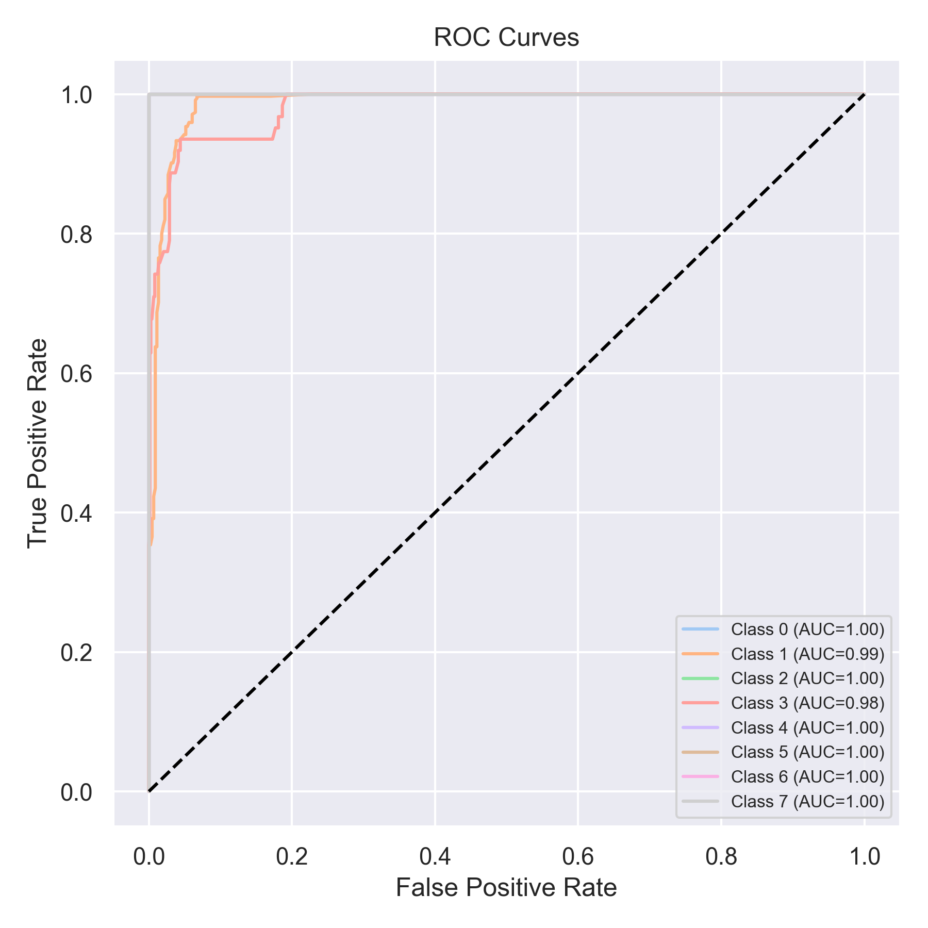

Evaluation: K-Nearest Neighbors
Accuracy: 0.683944374209861
Precision: 0.7408771597792436
Recall: 0.683944374209861
F1 Score: 0.6852028289406612
Jaccard Index: 0.523426435915808
Matthews CorrCoef: 0.6301032580713618
Cohen’s Kappa: 0.615745589575484
Specificity: 0.9546435444973869
AUC: 0.9885749796835412
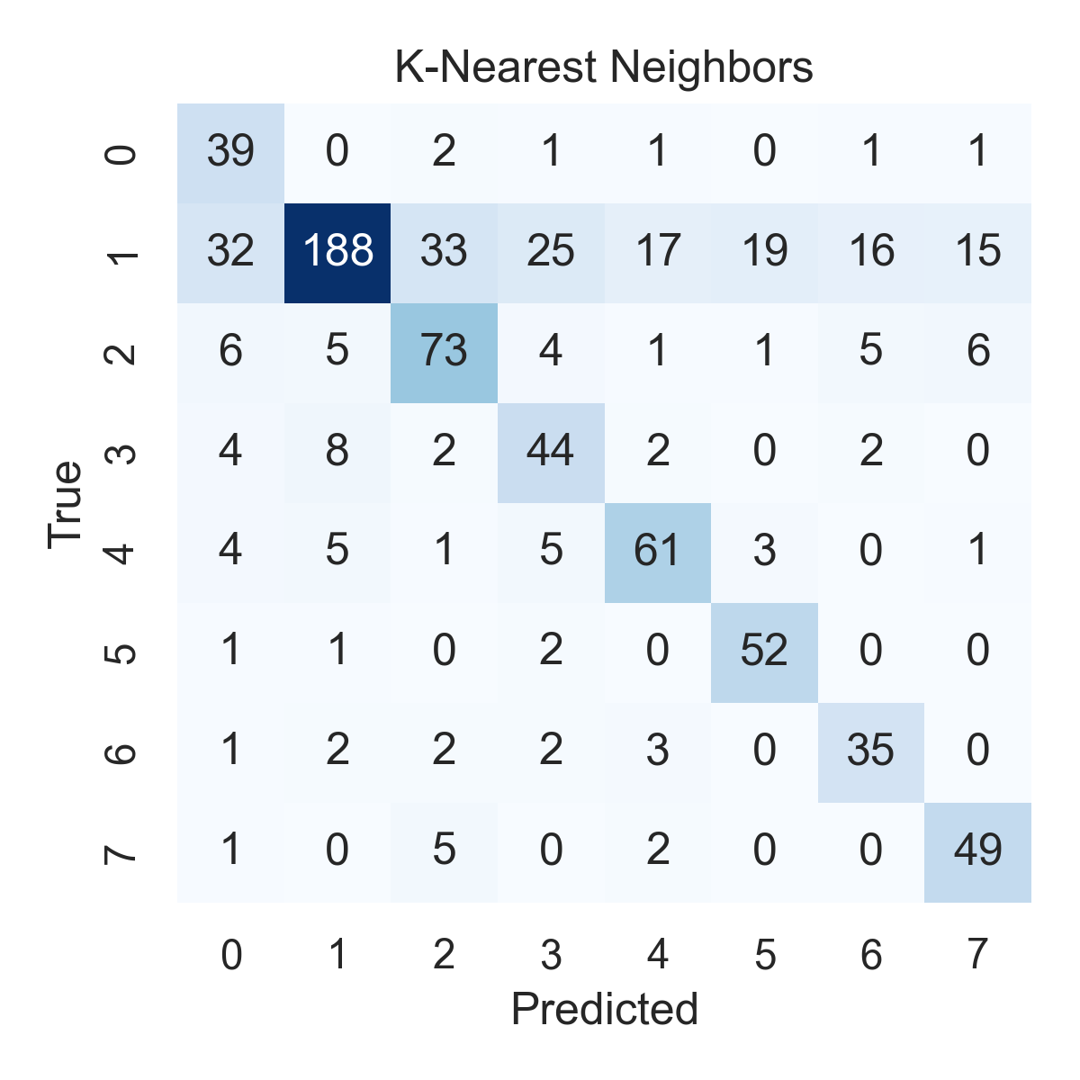

Combined ROC Curves
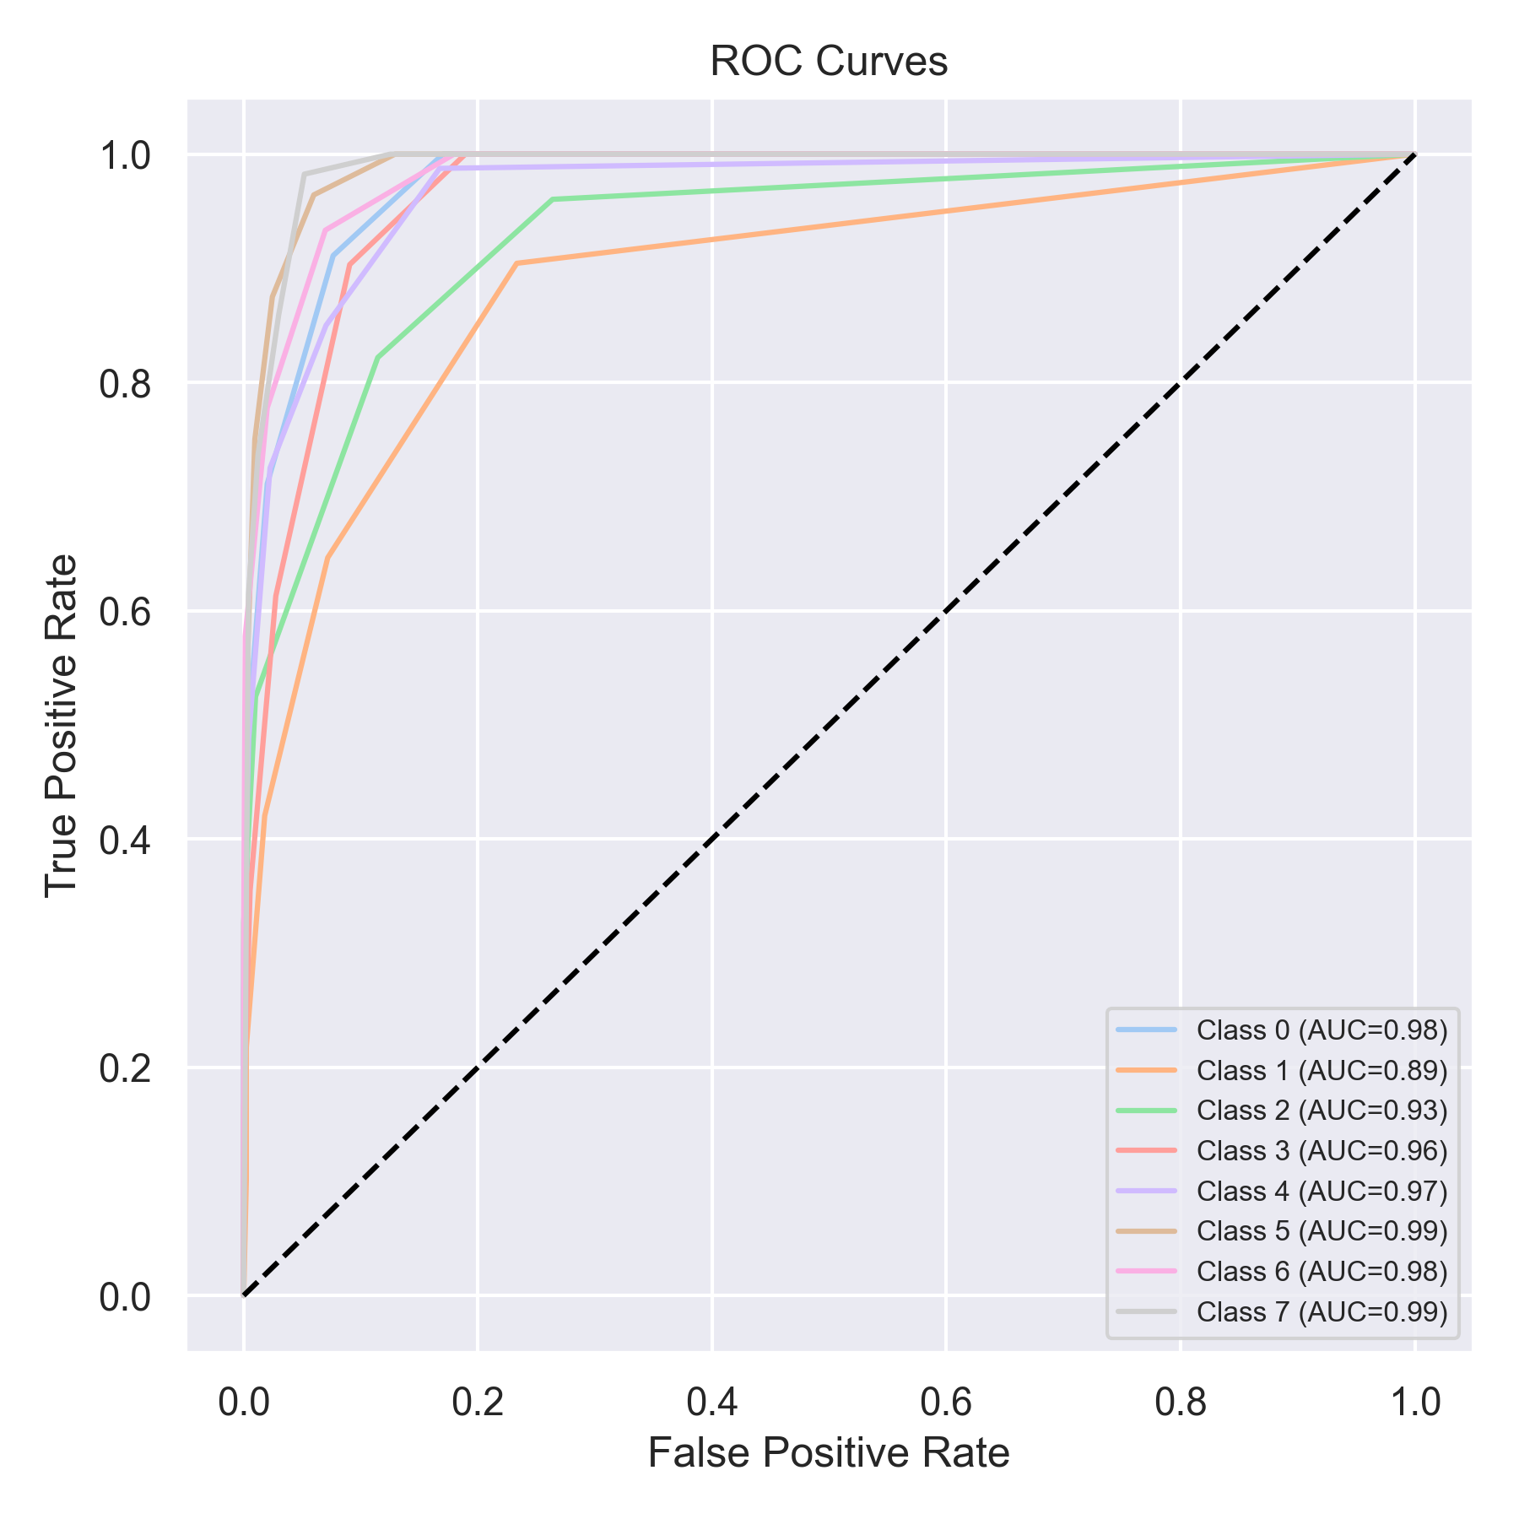

Evaluation: Decision Tree
Accuracy: 0.7661188369152971
Precision: 0.8808033956167947
Recall: 0.7661188369152971
F1 Score: 0.7987895143809577
Jaccard Index: 0.7171821184810051
Matthews CorrCoef: 0.7400019235678399
Cohen’s Kappa: 0.7146626004925427
Specificity: 0.9653408287044726
AUC: 1.0
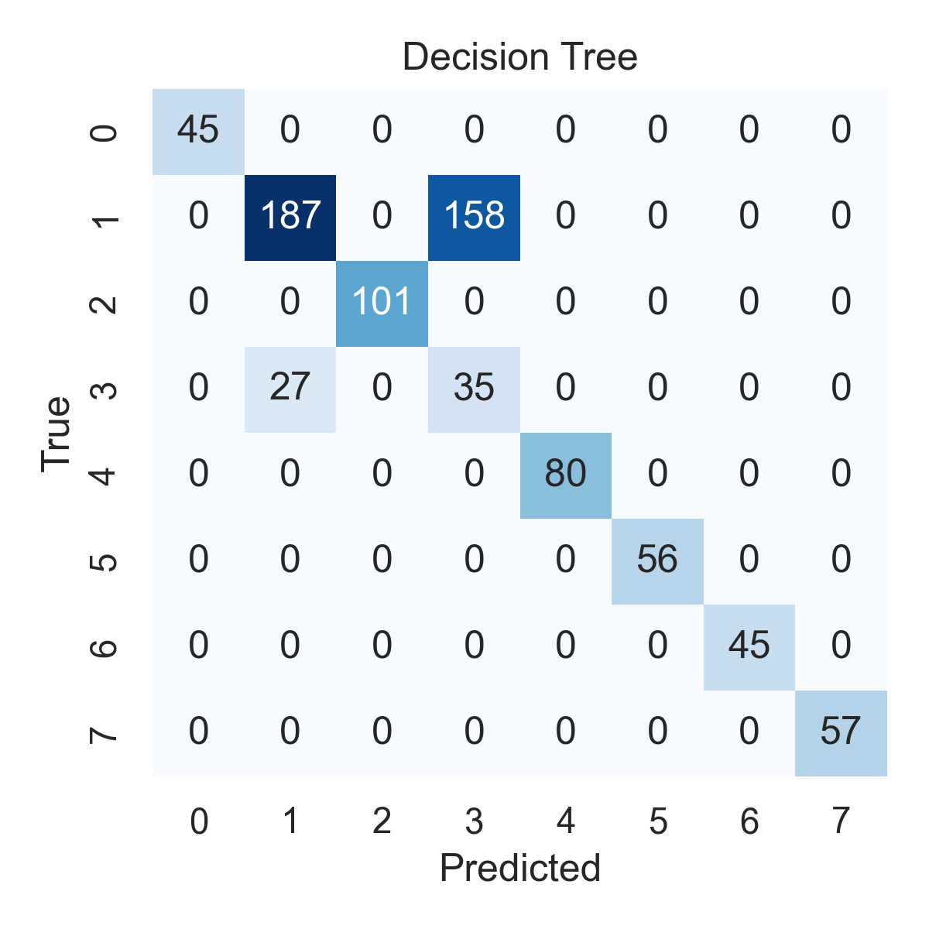

Combined ROC Curves
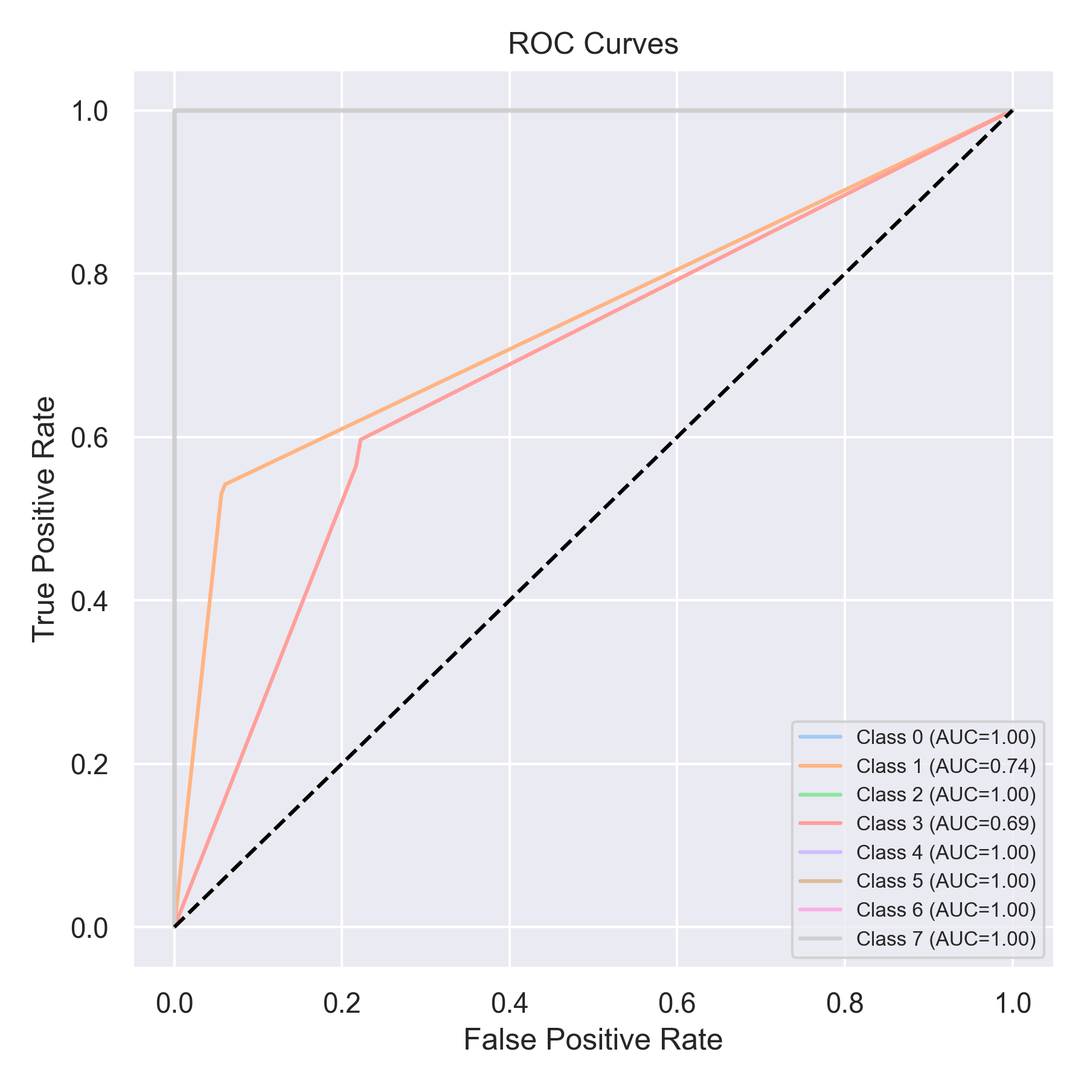

Evaluation: Extra Trees
Accuracy: 0.9835651074589128
Precision: 0.9836835262334337
Recall: 0.9835651074589128
F1 Score: 0.9836189204016887
Jaccard Index: 0.9690784611908122
Matthews CorrCoef: 0.9784019630370693
Cohen’s Kappa: 0.9783997361671557
Specificity: 0.9971181113018017
AUC: 1.0
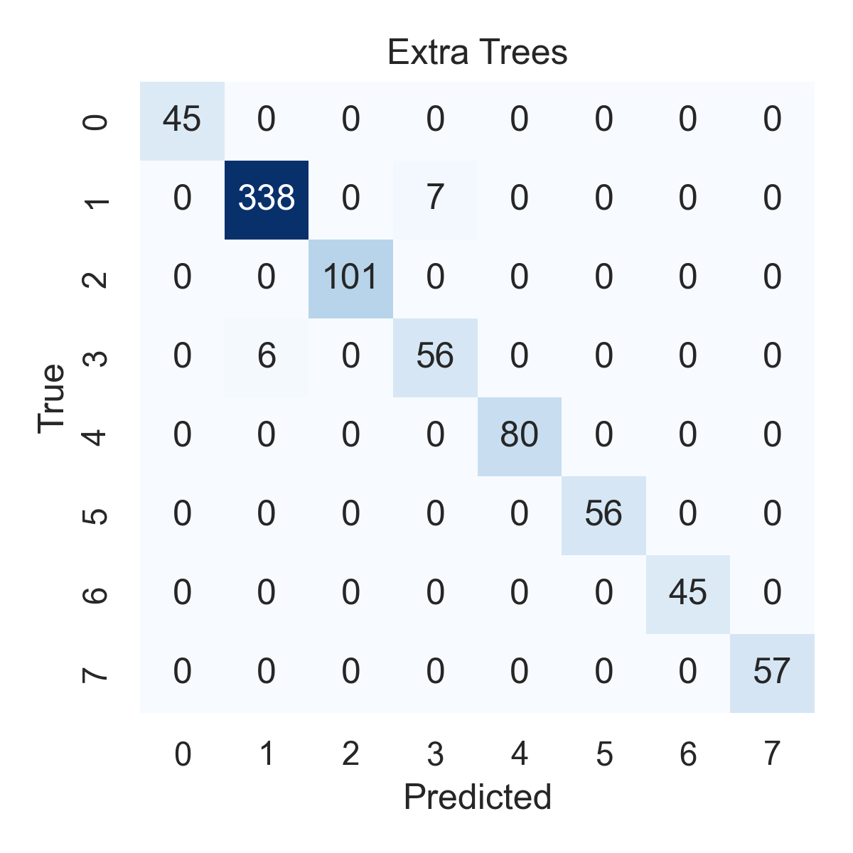

Combined ROC Curves
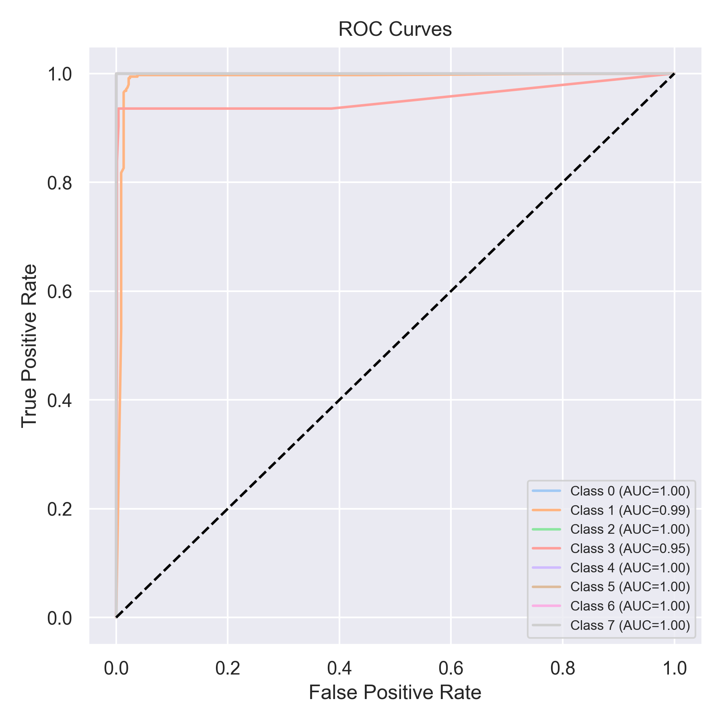

Evaluation: Bagging Classifier
Accuracy: 0.7635903919089759
Precision: 0.8837690164818061
Recall: 0.7635903919089759
F1 Score: 0.796352580604816
Jaccard Index: 0.7141292118378085
Matthews CorrCoef: 0.7401069534875844
Cohen’s Kappa: 0.7125296620133826
Specificity: 0.9652154957648231
AUC: 1.0
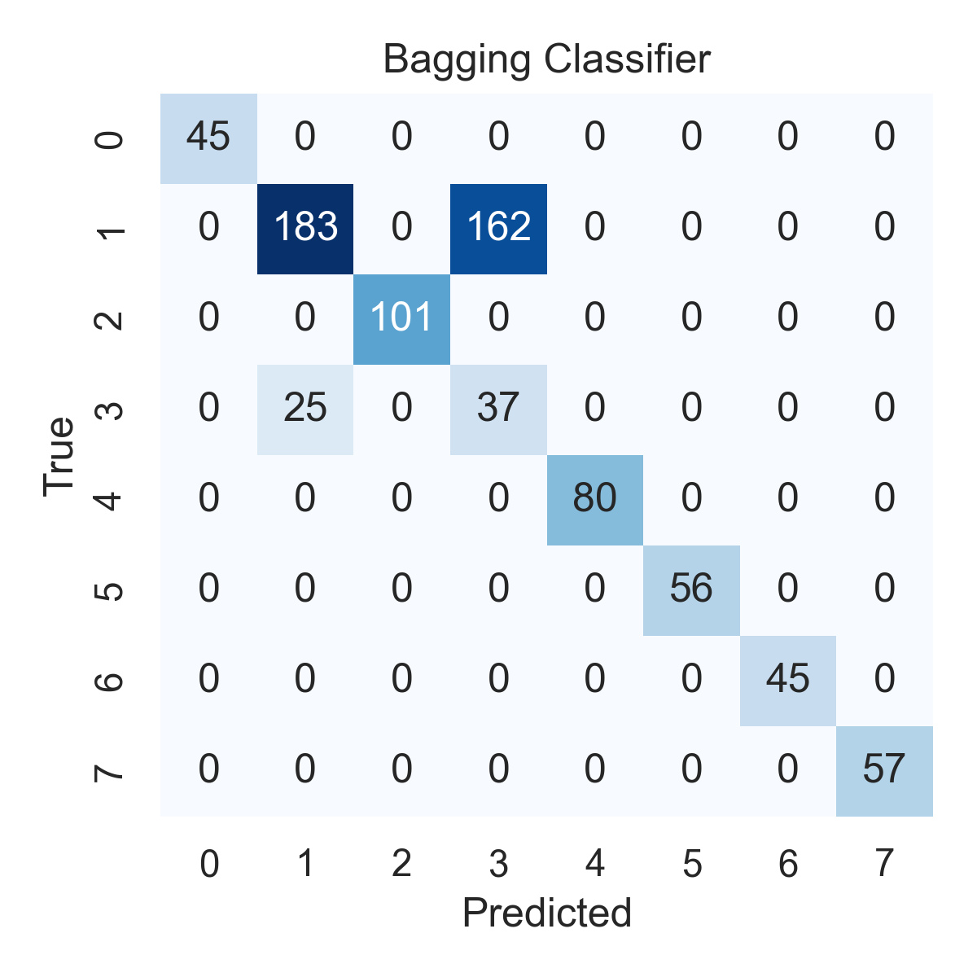

Combined ROC Curves
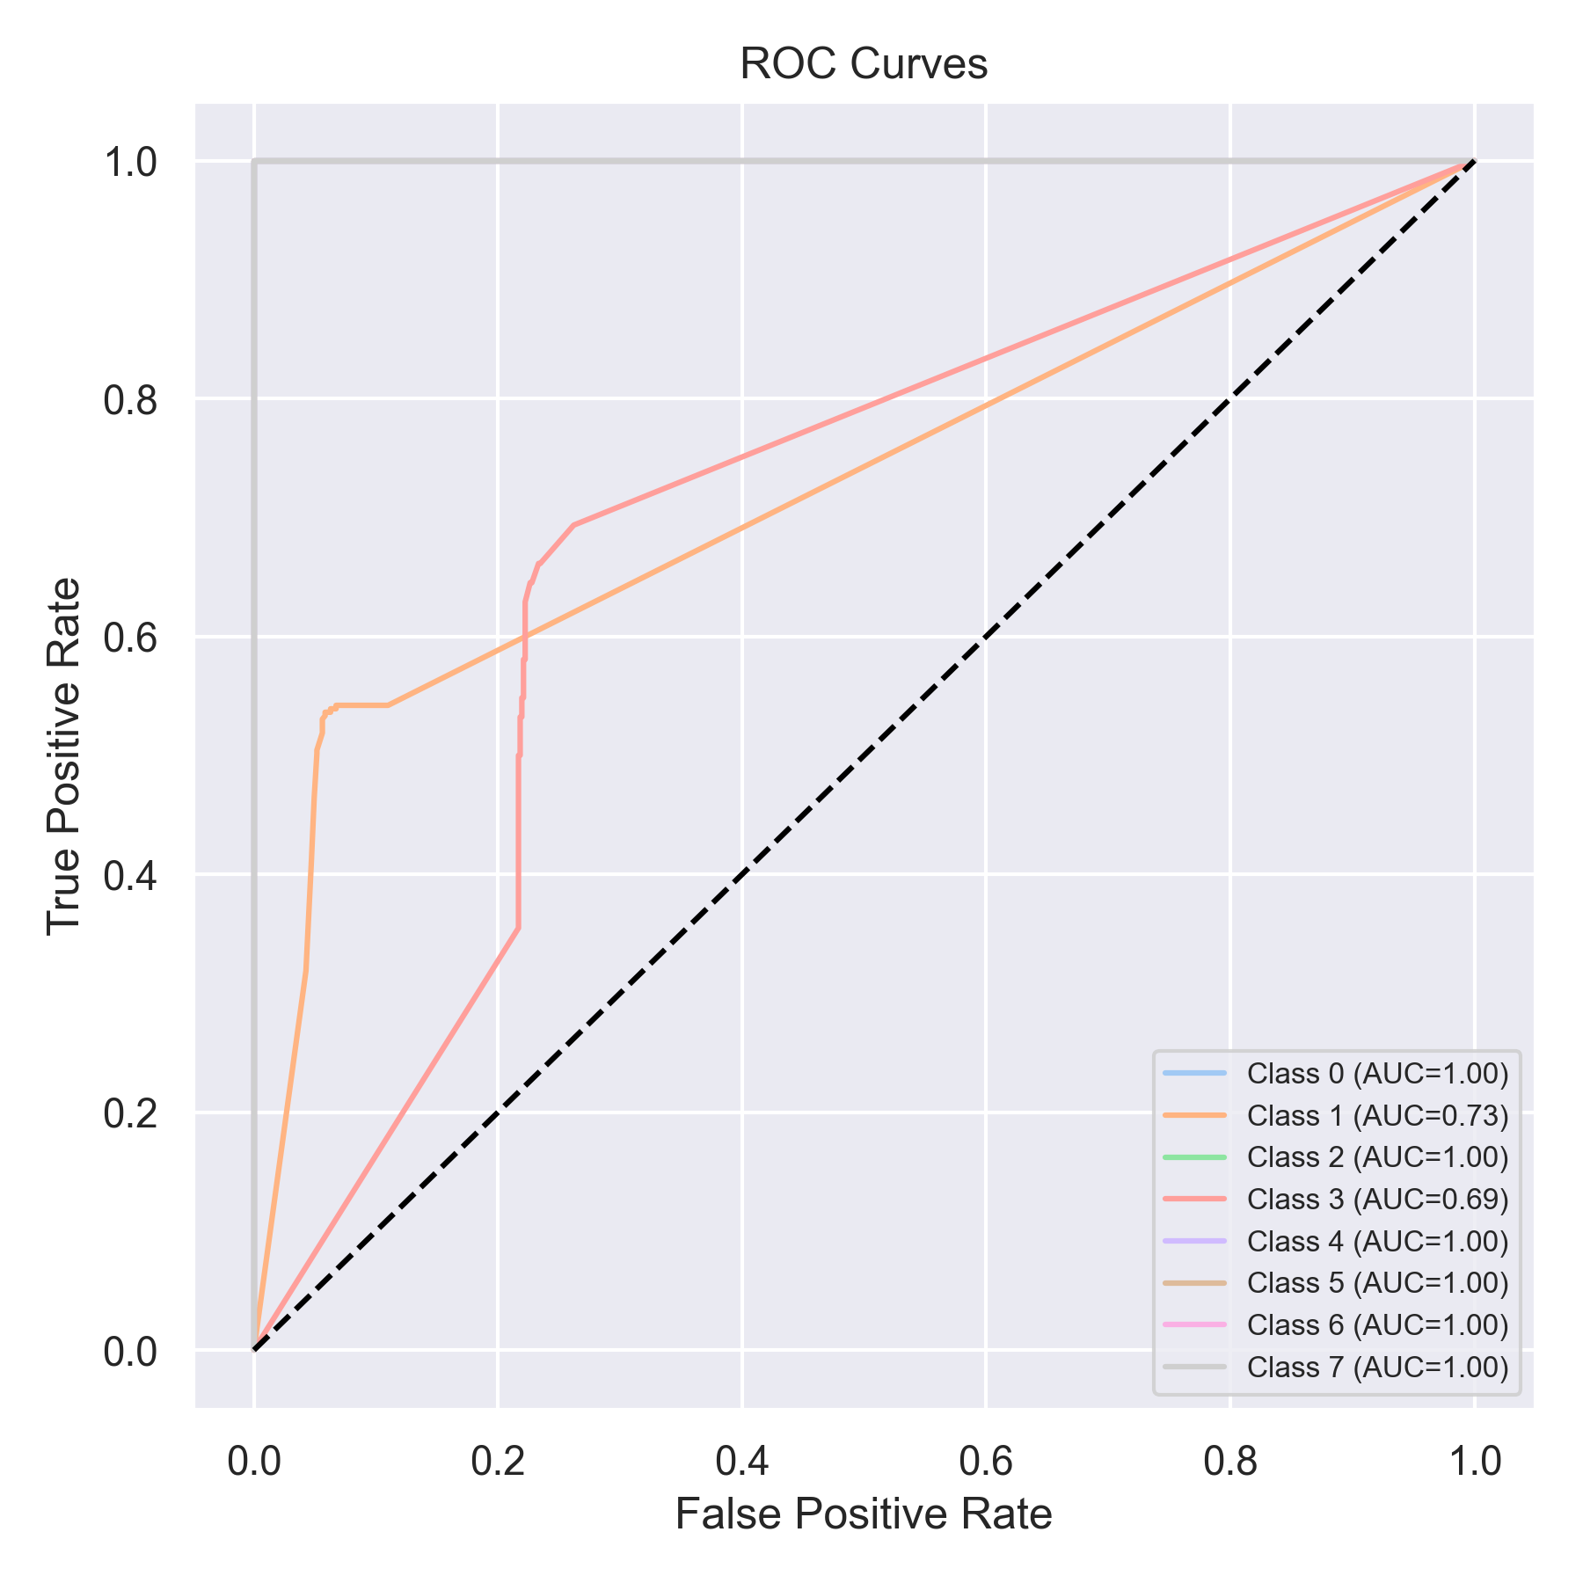

Evaluation: XGBoost
Accuracy: 0.7648546144121365
Precision: 0.8859418457648546
Recall: 0.7648546144121365
F1 Score: 0.7973890427616024
Jaccard Index: 0.7150637397199329
Matthews CorrCoef: 0.7422634980620209
Cohen’s Kappa: 0.7142241128139386
Specificity: 0.965495764823119
AUC: 1.0
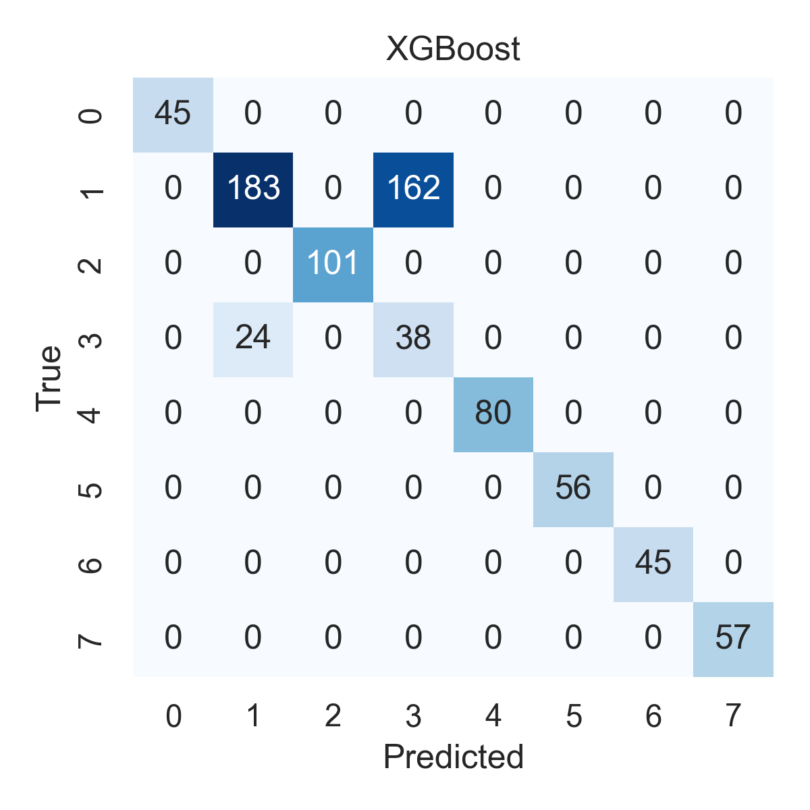

Combined ROC Curves
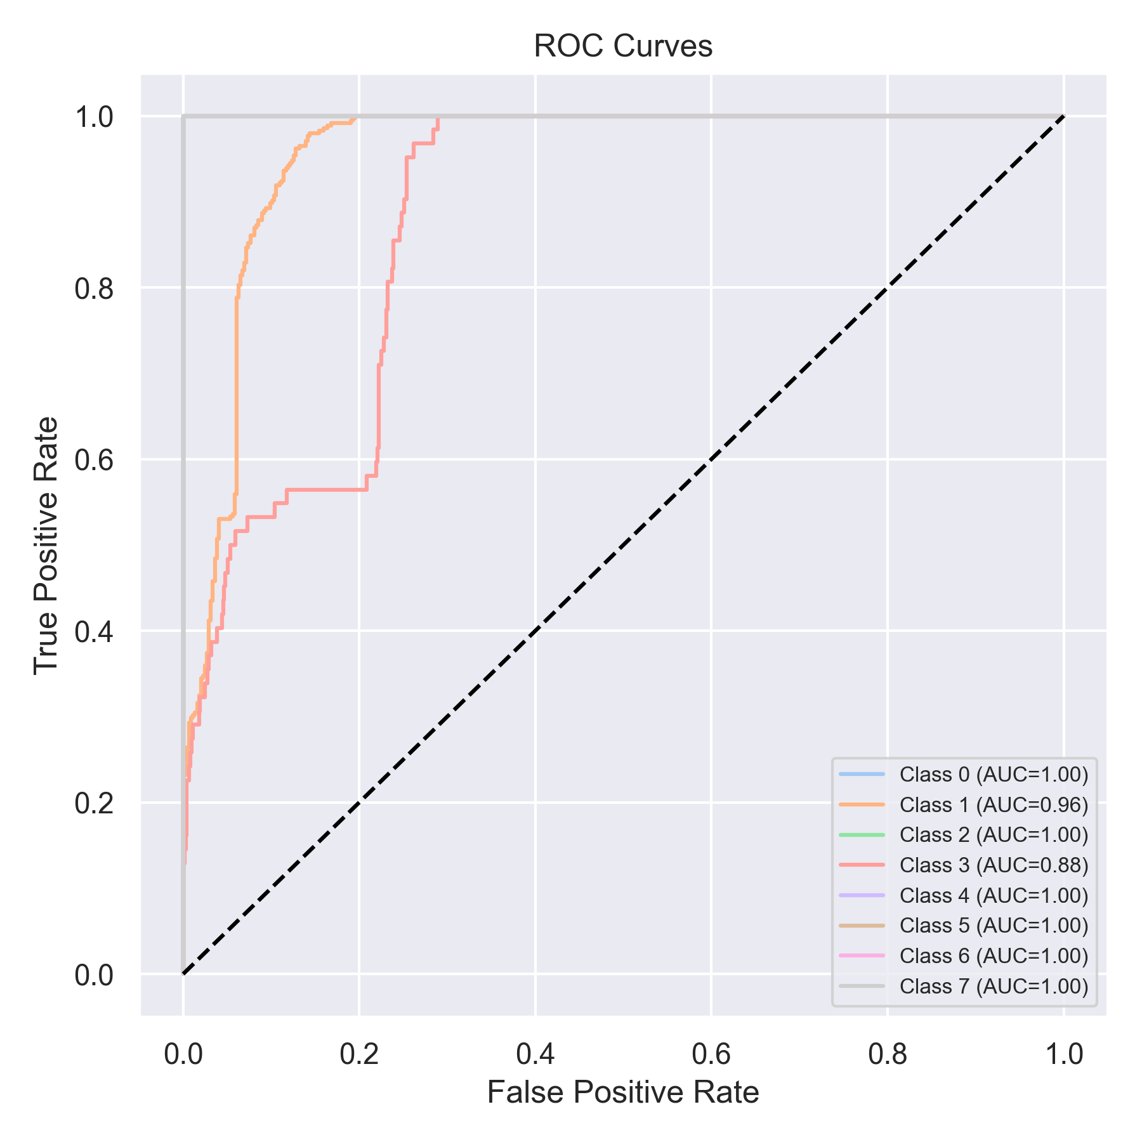

Evaluation: LightGBM
Accuracy: 0.797724399494311
Precision: 0.8920797492323023
Recall: 0.797724399494311
F1 Score: 0.8260865029250748
Jaccard Index: 0.7477313285228474
Matthews CorrCoef: 0.7692461366237142
Cohen’s Kappa: 0.7503284632653786
Specificity: 0.9698451253944528
AUC: 1.0
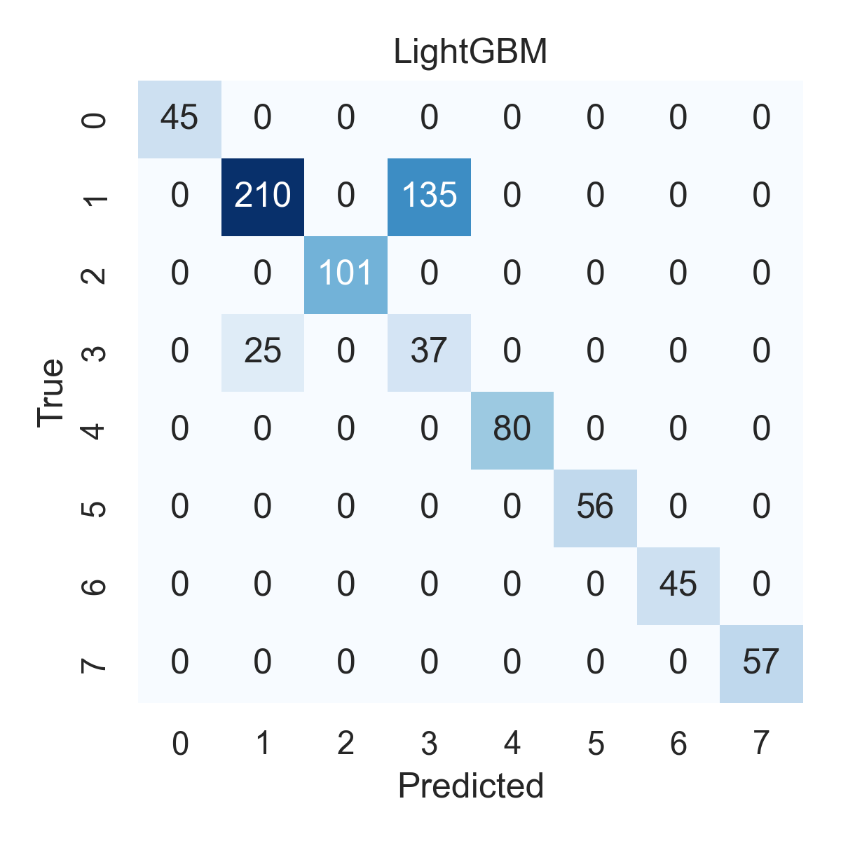

Combined ROC Curves
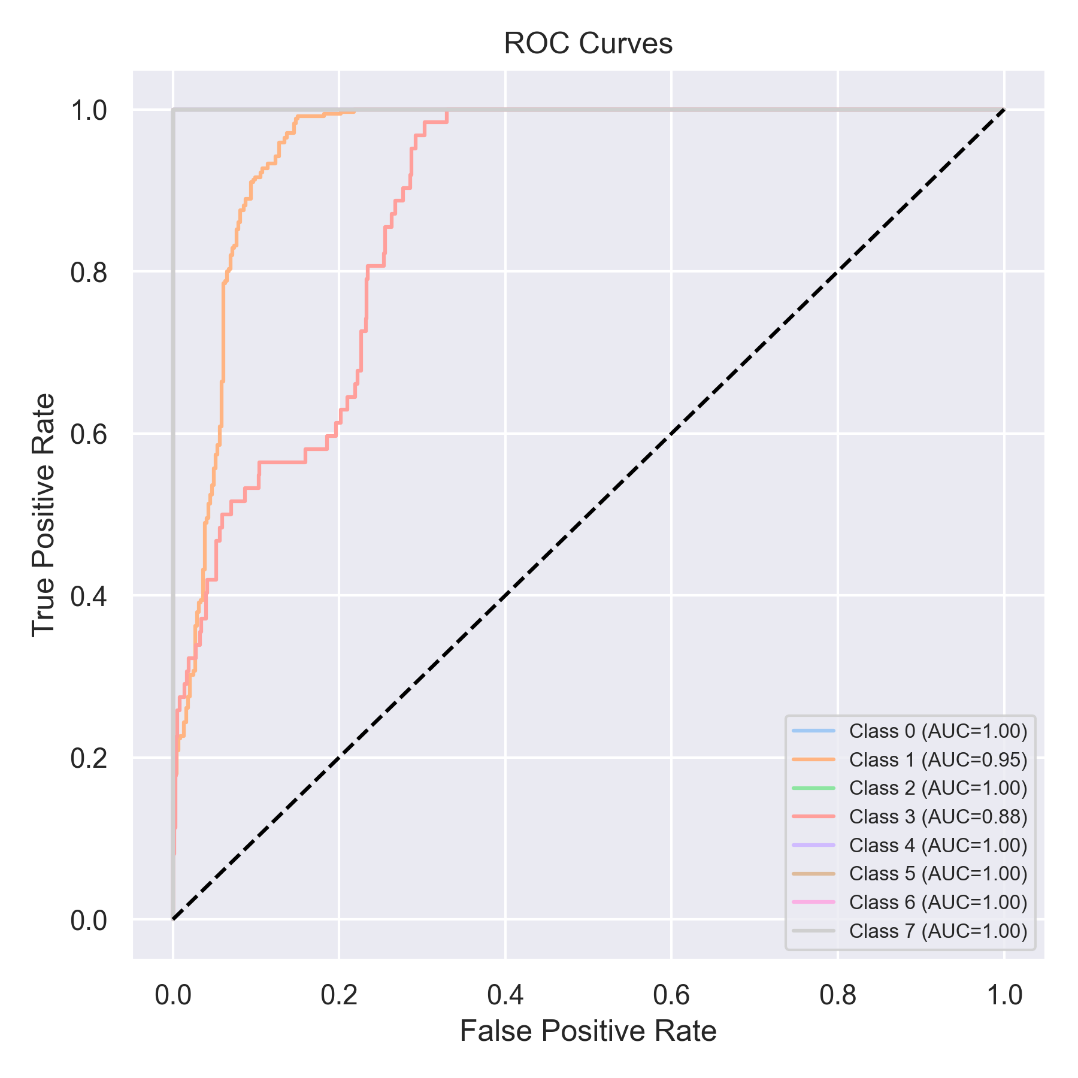

Evaluation: CatBoost
Accuracy: 0.056890012642225034
Precision: 0.003236473538432524
Recall: 0.056890012642225034
F1 Score: 0.006124522892105566
Jaccard Index: 0.003236473538432524
Matthews CorrCoef: 0.0
Cohen’s Kappa: 0.0
Specificity: 0.875
AUC: 1.0
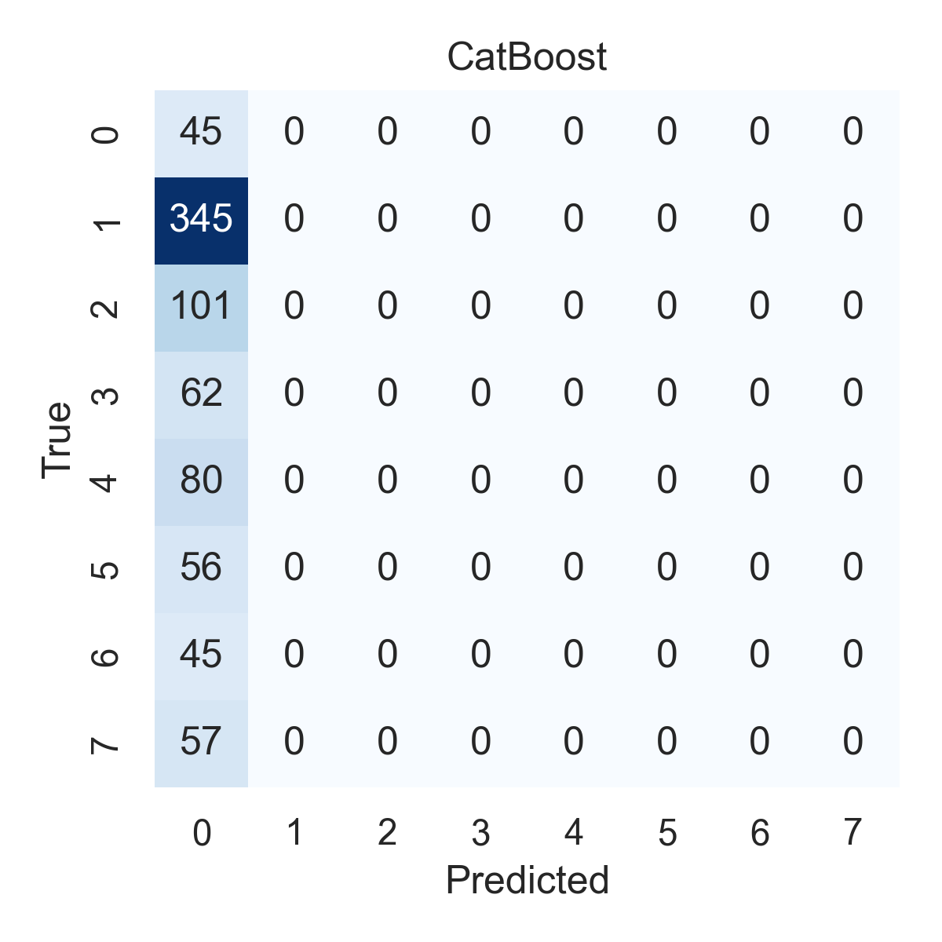

Combined ROC Curves
